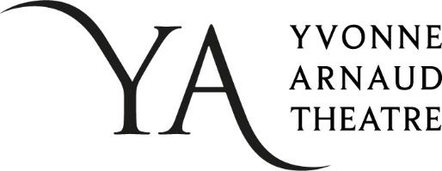
YVONNE ARNAUD THEATRE
EQUAL OPPORTUNITIES MONITORING FORM
We are committed to ensuring that all job applicants and members of staff are treated equally, without discrimination because of gender, sexual orientation, marital or civil partner status, gender reassignment, race, colour, nationality, ethnic or national origin, religion or belief, disability or age. This form is intended to help us maintain equal opportunities best practice and identify barriers to workforce equality and diversity.
Please complete this form and return it with your application. The form will be separated from your application on receipt. The information on this form will be used for monitoring purposes only and will play no part in the recruitment process.
All questions are optional. You are not obliged to answer any of these questions but the more information you supply, the more effective our monitoring will be. All information supplied will be treated in the strictest confidence. It will not be placed on your personnel file.
Thank you for your assistance.

ABOUT THE VACANCY
Please state which job you have applied for and the closing date given for applications.
Job applied for: | Click here to enter text.
Closing date for applications: | Click here to enter text.
Where did you hear about this job (please tick)?
☐ Recruitment Company ☐ Friend/Colleague
☐ Newspaper (please state): ☐ Online publication/job-board (please state):
Click here to enter text. Click here to enter text.
☐ Social media (please state): ☐ Other (please state):
Click here to enter text. Click here to enter text.

GENDER AND SEXUAL ORIENTATION
What is your gender (please tick)?
☐ Female ☐ Male ☐ Non-Binary
☐ Prefer to use your own term ☐Prefer not to say
If you prefer to use your own term, please specify here
Click or tap here to enter text.

Do you identify as trans?
☐ Yes ☐ No ☐ Prefer not to say
If you prefer your own term, please specify here
Click or tap here to enter text.

What is your sexual orientation?
☐ Heterosexual/straight ☐ Gay man ☐ Gay woman/lesbian
☐ Bisexual ☐ Queer
☐ Prefer to use your own term ☐ Prefer not to say
If you prefer to use your own term, please specify here
Click or tap here to enter text.

ETHNIC GROUP
How would you describe your nationality and/or ethnicity (please tick)?
A  White: |  | B  Mixed race: |  | C  Asian or Asian British:
British - English, Scottish Welsh or Northern Irish | ☐ | White and Black Caribbean | ☐ | Indian | ☐
Irish | ☐ | White and Black African | ☐ | Pakistani | ☐
Other White background | ☐ | White and Asian | ☐ | Bangladeshi | ☐
 |  | Other Mixed background | ☐ | Other Asian background | ☐
D  Black or Black British: |  | E  Chinese and other groups:
Caribbean | ☐ | Chinese | ☐ | Prefer not to say | ☐
African | ☐ | Other ethnic group | ☐
Other Black background | ☐

RELIGION OR BELIEF
Please describe your religion or other strongly-held belief.
I would describe my religion or belief as: Click here to enter text.
I have no particular religion or belief ☐
Prefer not to say ☐

DISABILITY
The Equality Act 2010 defines a disability as a "physical or mental impairment which has a substantial and long-term adverse effect on a person's ability to carry out normal day-to-day activities". An effect is long-term if it has lasted, or is likely to last, more than 12 months.
Do you consider that you have a disability under the Equality Act (please tick)?
☐ Yes ☐ No ☐ Prefer not to say
☐Used to have a disability ☐ Not sure
but have now recovered

We thank you for taking the time to complete this form.
If you are returning an electronic copy please save the document as
“your name - job title you are applying for - date of your application”.

